AWS TASK

LAUNCHING COMPLETE

INFRASTURUCTURE WITH

EC2,EBS,S3&CLOUDFRONT

USING TERRAFORM

What is Terraform?

Terraform is a tool for building, changing, and versioning infrastructure safely and efficiently. Terraform can manage existing and popular service providers as well as custom in-house solutions.

Configuration files describe to Terraform the components needed to run a single application or your entire datacenter. Terraform generates an execution plan describing what it will do to reach the desired state, and then executes it to build the described infrastructure. As the configuration changes, Terraform is able to determine what changed and create incremental execution plans which can be applied.

The infrastructure Terraform can manage includes low-level components such as compute instances, storage, and networking, as well as high-level components such as DNS entries, SaaS features, etc.

Task Description->

Create/launch Application using Terraform

1. Create the key and security group which allow the port 80.

2. Launch EC2 instance.

3. In this Ec2 instance use the key and security group which we have created in step 1.

4. Launch one Volume (EBS) and mount that volume into /var/www/html

5. Developer have uploded the code into github repo also the repo has some images.

6. Copy the github repo code into /var/www/html

7. Create S3 bucket, and copy/deploy the images from github repo into the s3 bucket and change the permission to public readable.

8 Create a Cloudfront using s3 bucket(which contains images) and use the Cloudfront URL to update in code in /var/www/html

STEP 1->In this step I have created the created the key and the security group and allowed the port 22,80&443 for SSH ,HTTP & HTTPS/SSL respectively

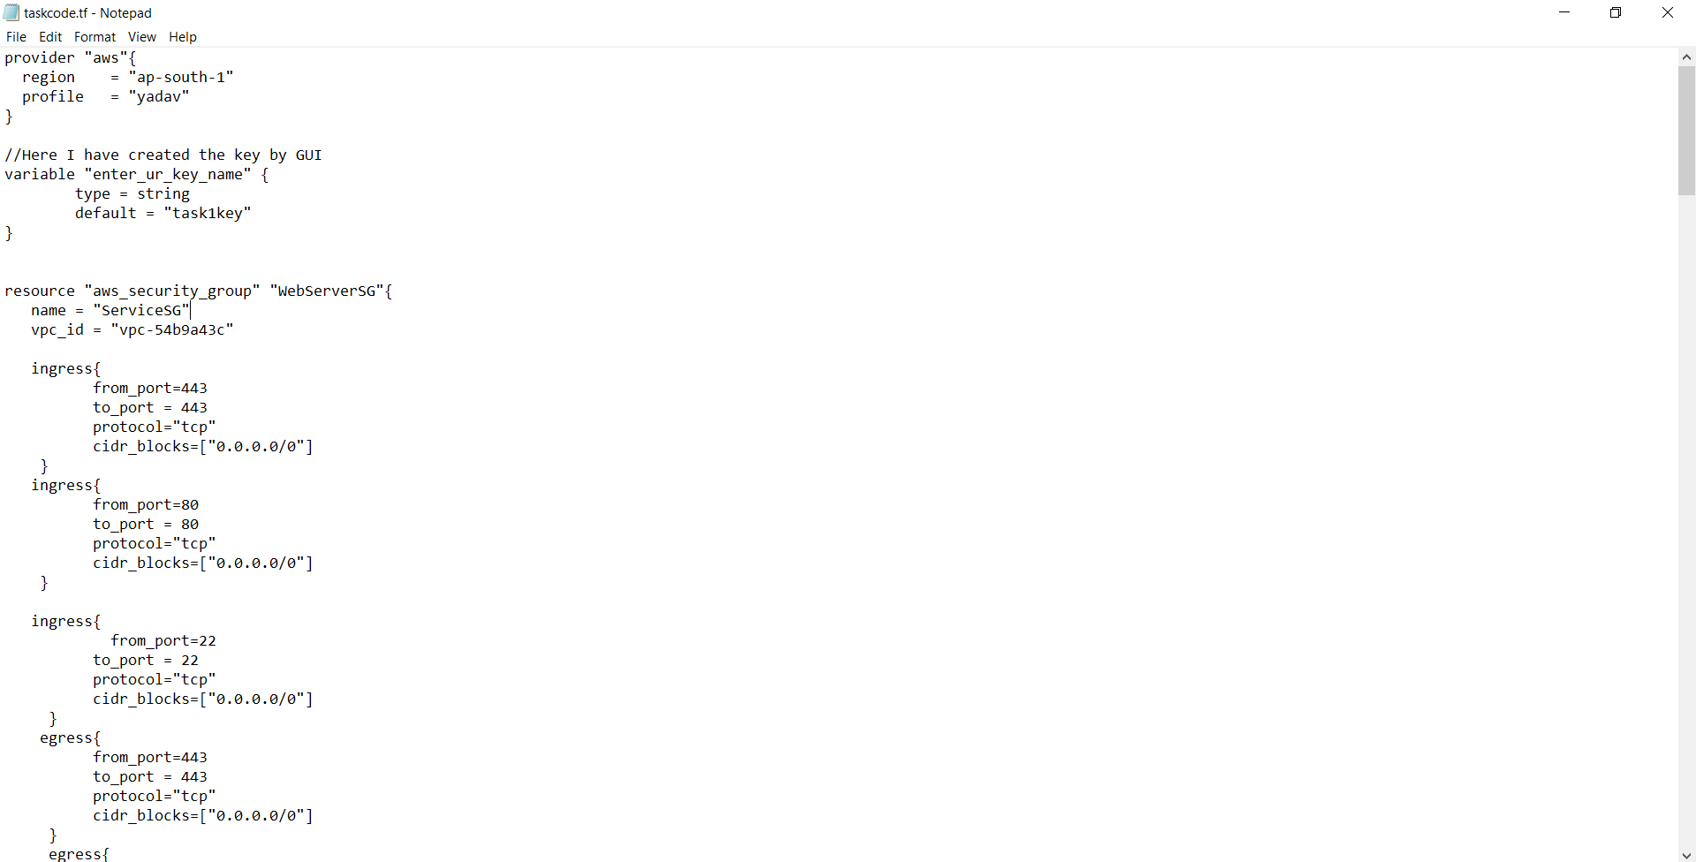

STEP 2&3->In this step I have created the instance using the security group and key created in the last step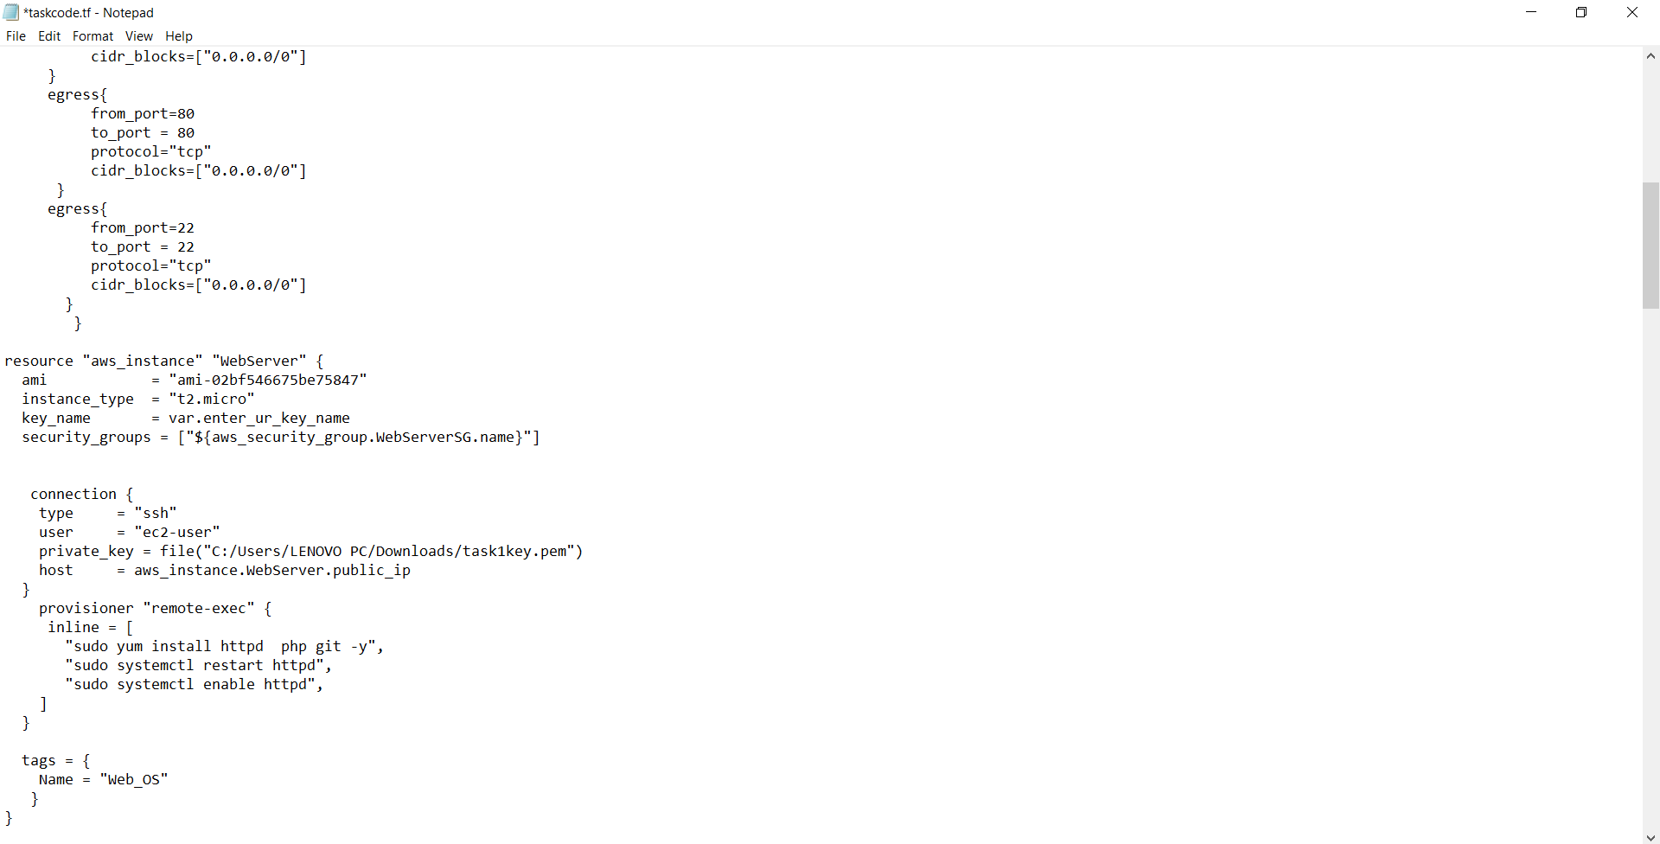

STEP 4&5->In this step I have created a volume and attached it to the instance and mounted it to the directory /var/www/html , uploaded the code and image to github and copied the github repo to /var/www/html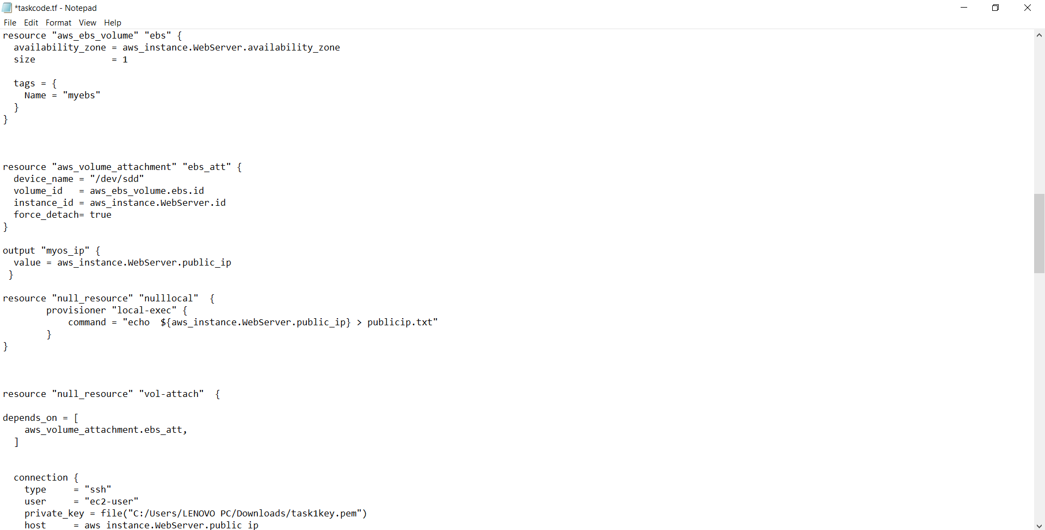

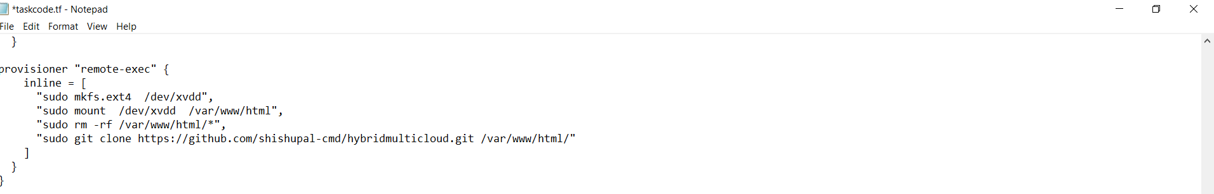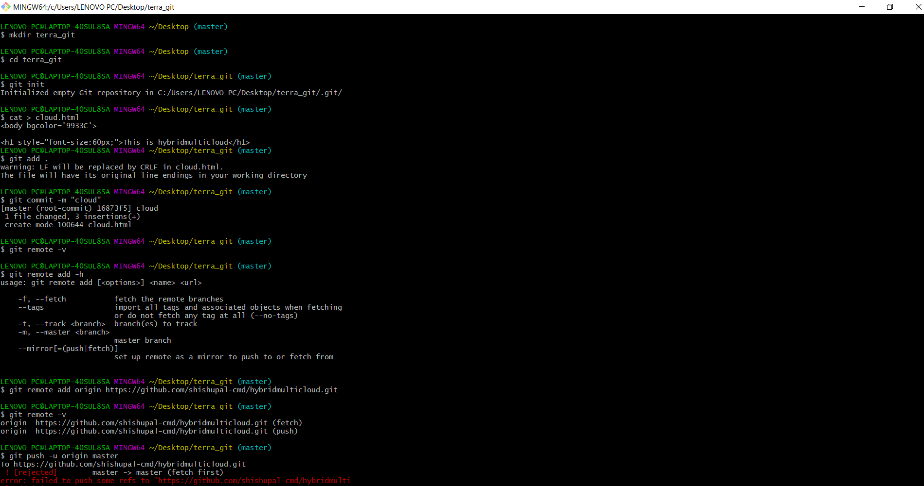

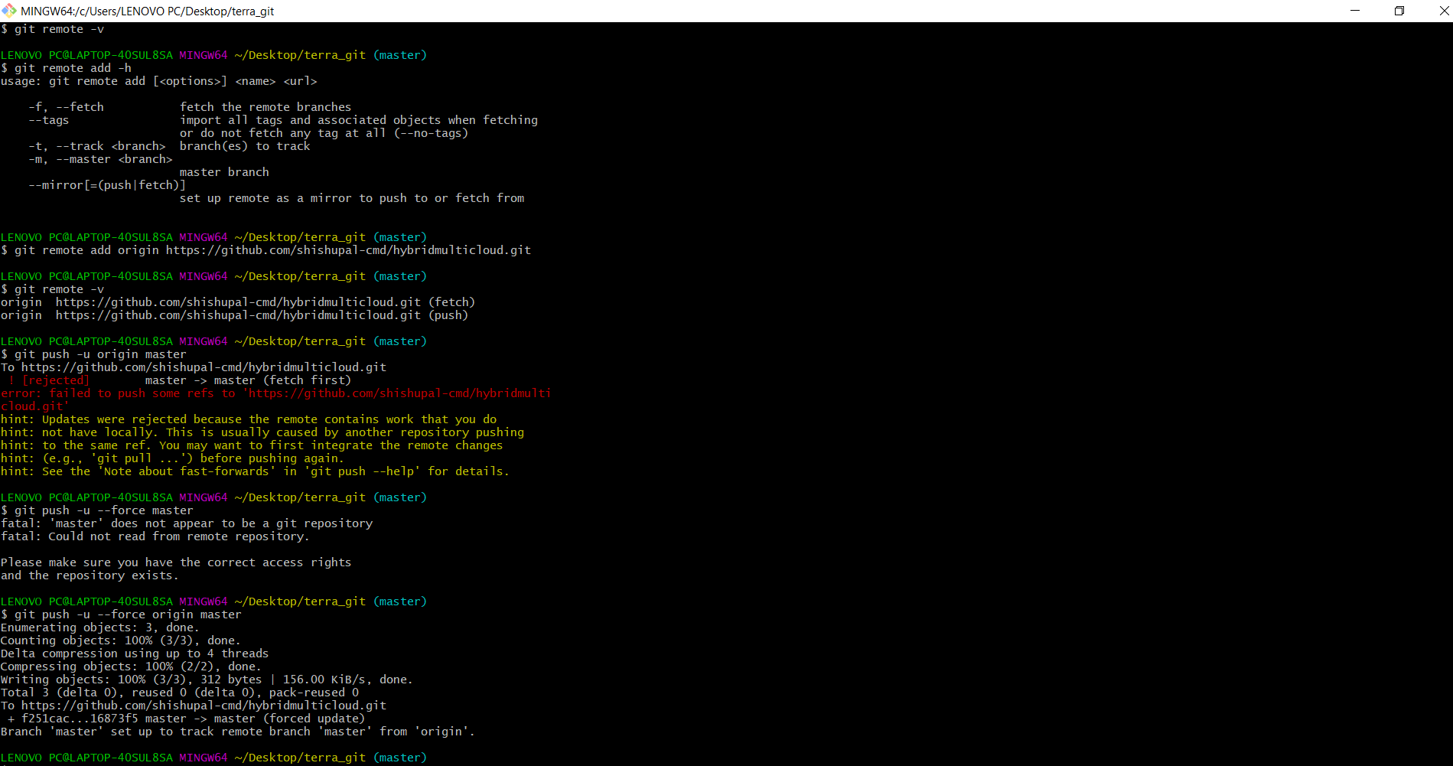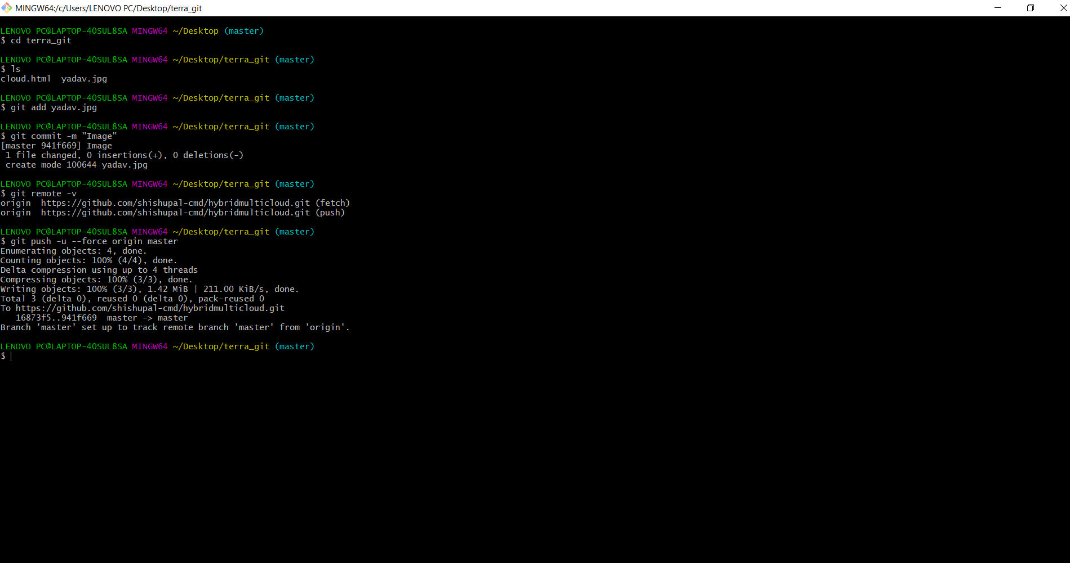

STEP 7-> In this step I have created the S3 bucket and made it public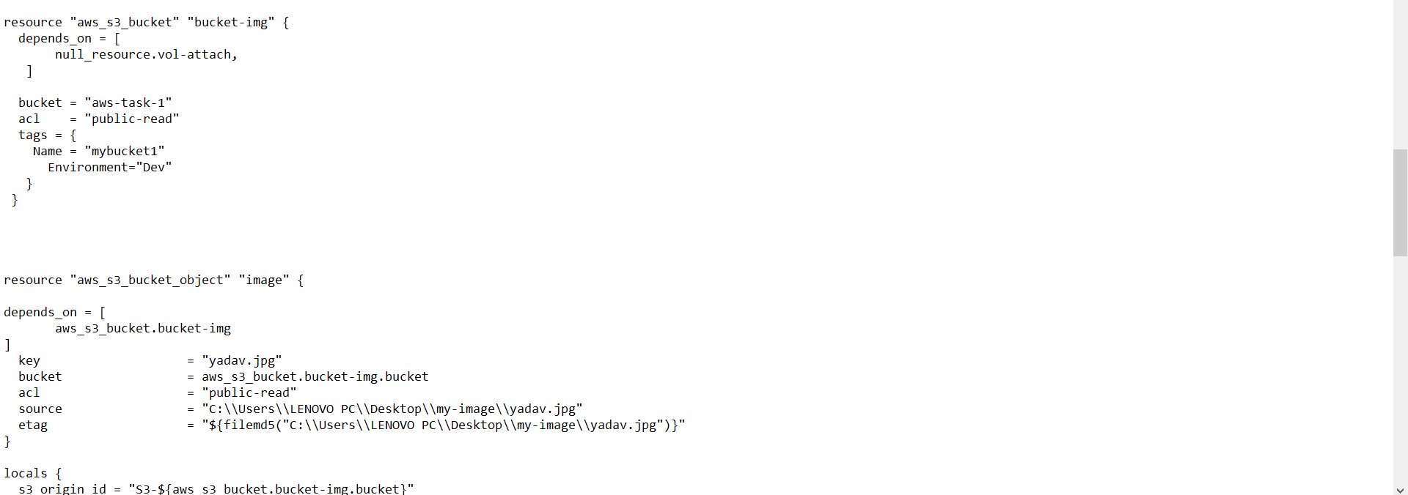

STEP 8->In this step I have created the cloudfront using the S3 bucket and changed the code in /var/www/html by using the url of object

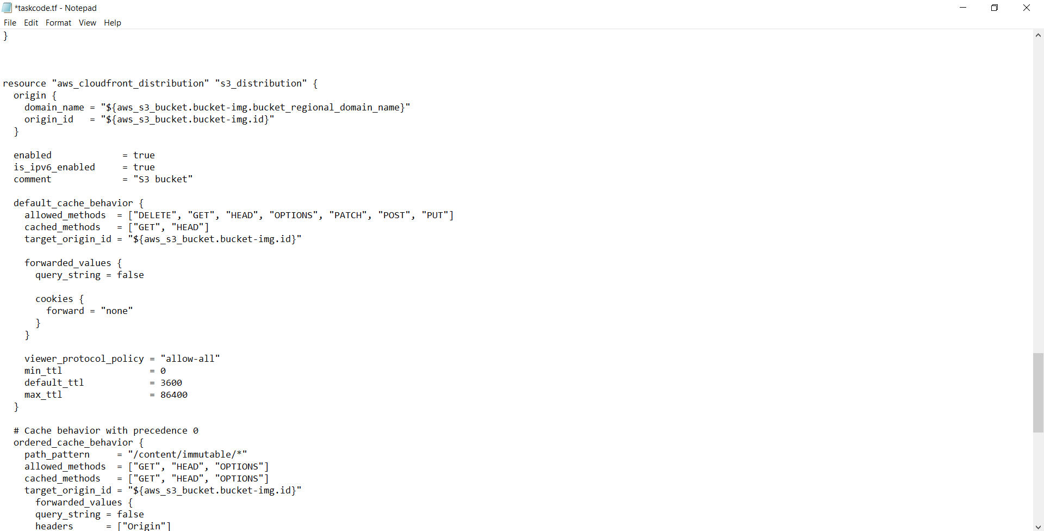

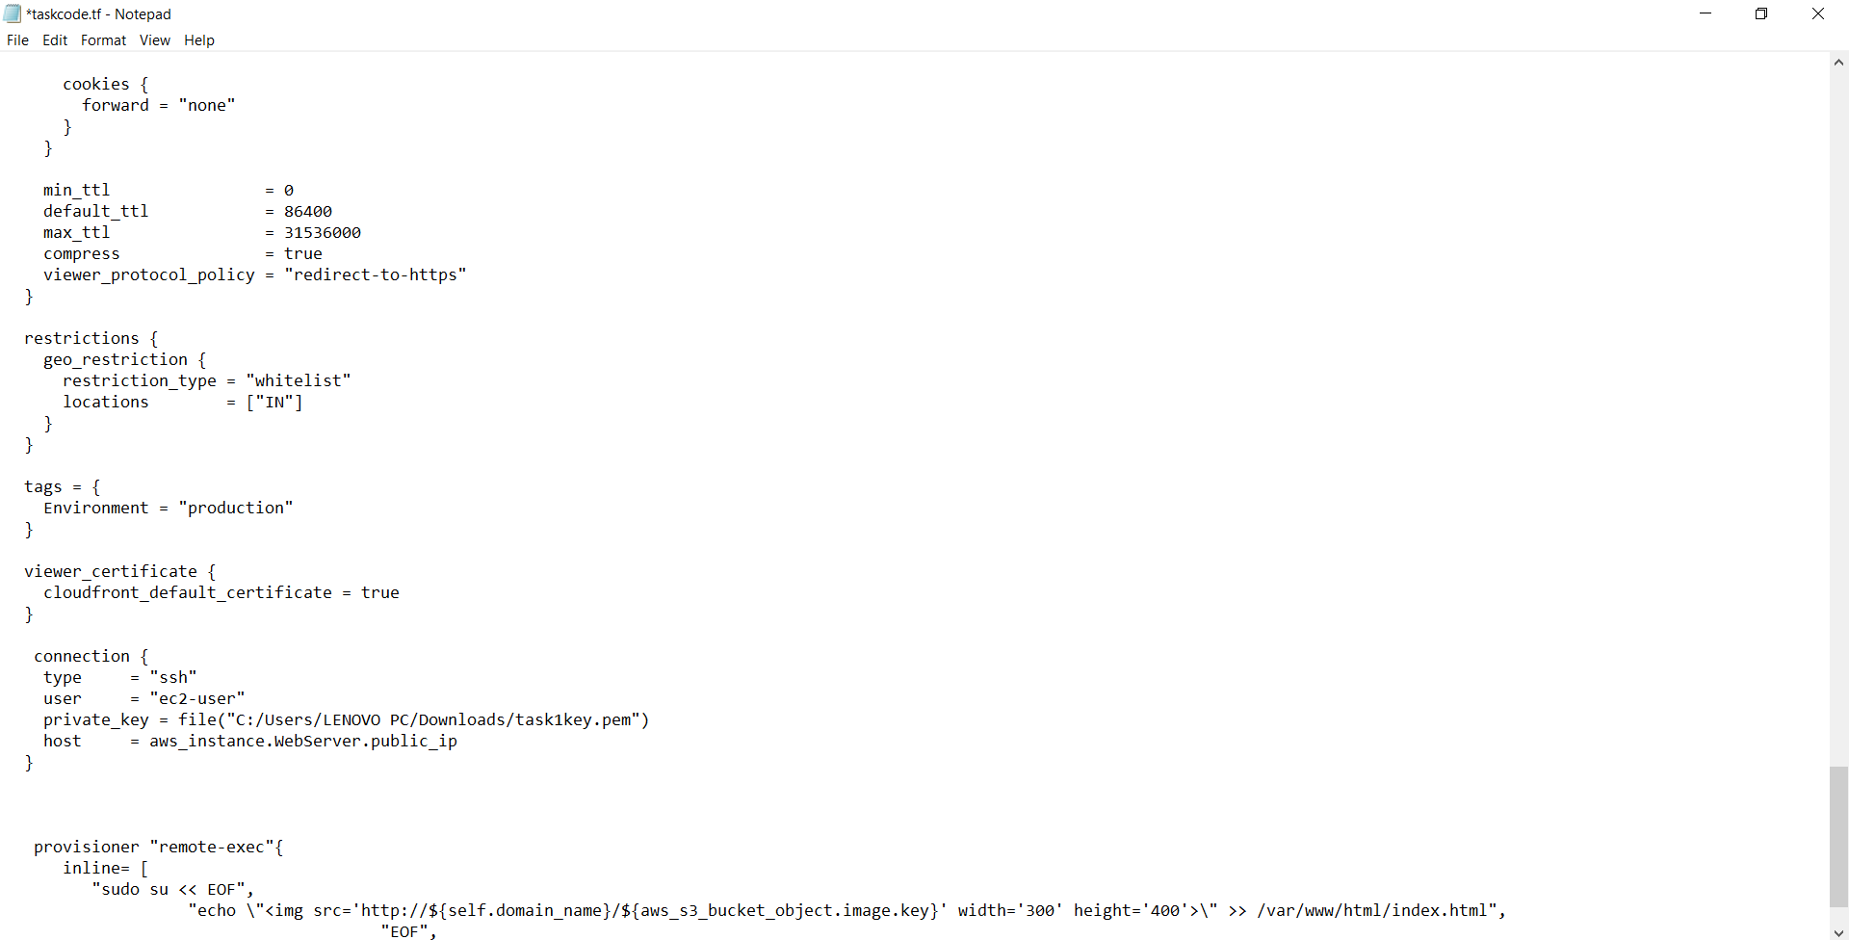

Then I have used the commands:

terraform init-To initialize the local directory and download the plugins

terraform validate-To see syntax of code

terraform apply –To create the infrastructure

Here is the ouput :

